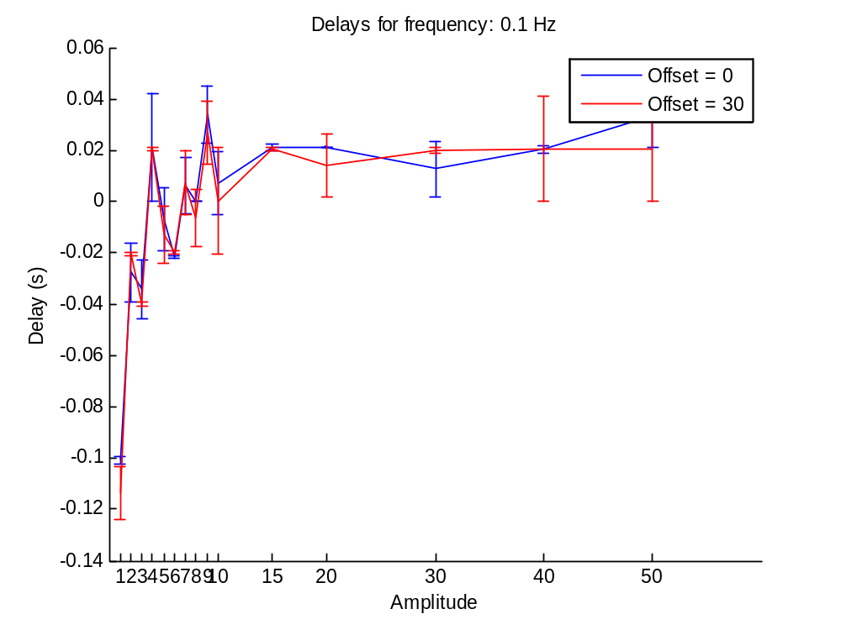
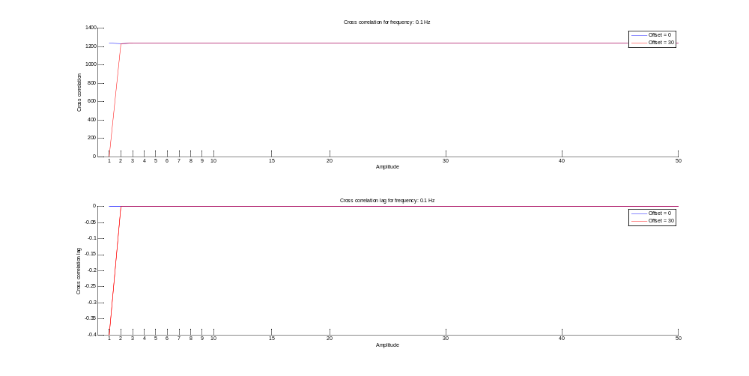

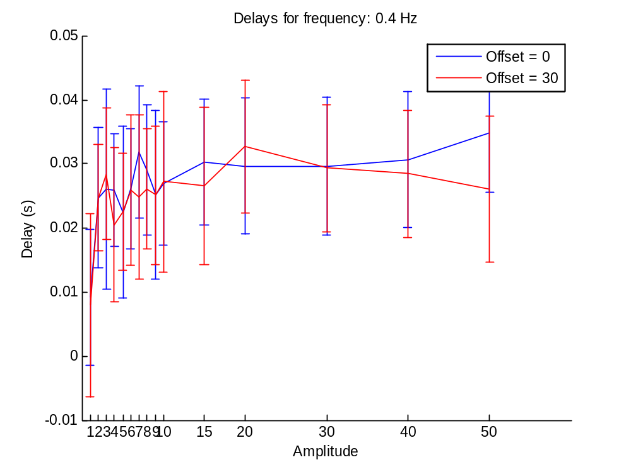
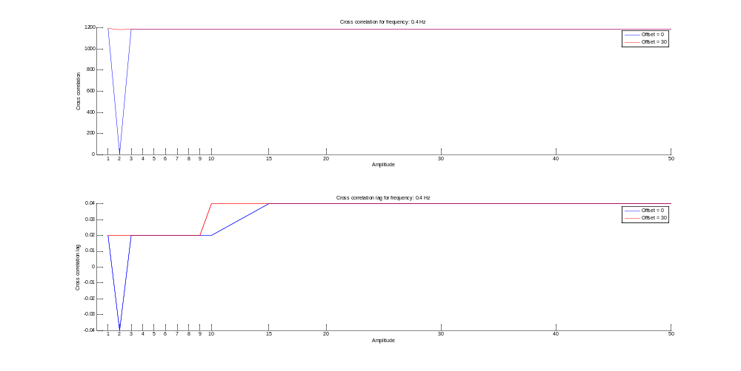

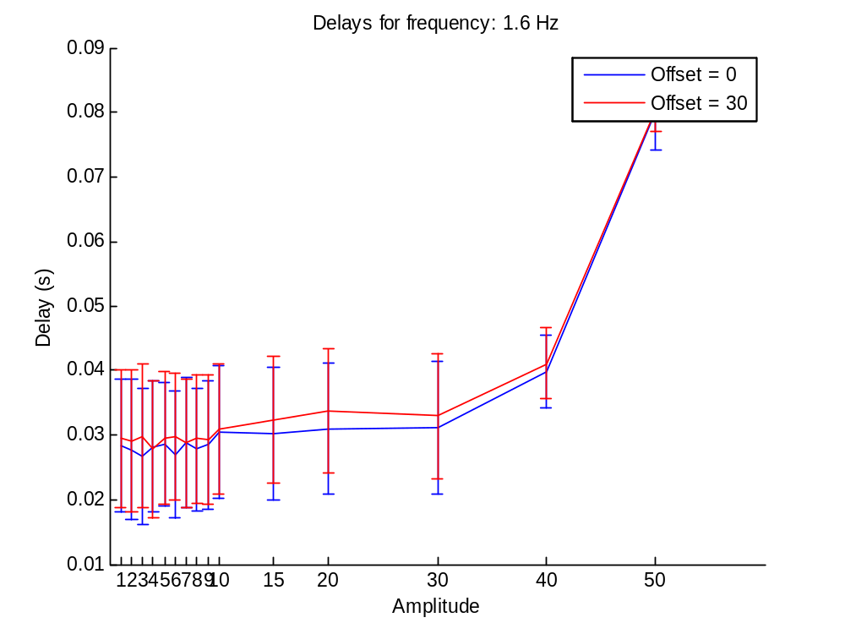
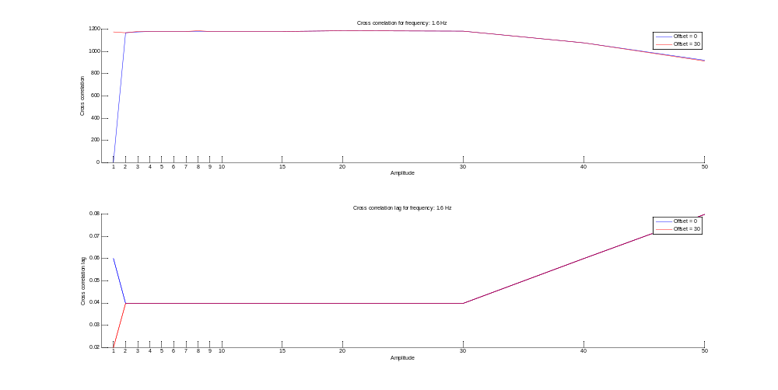

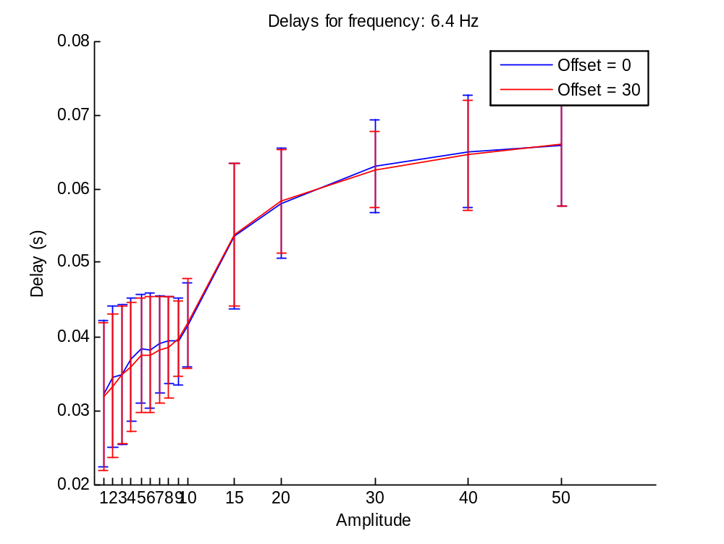
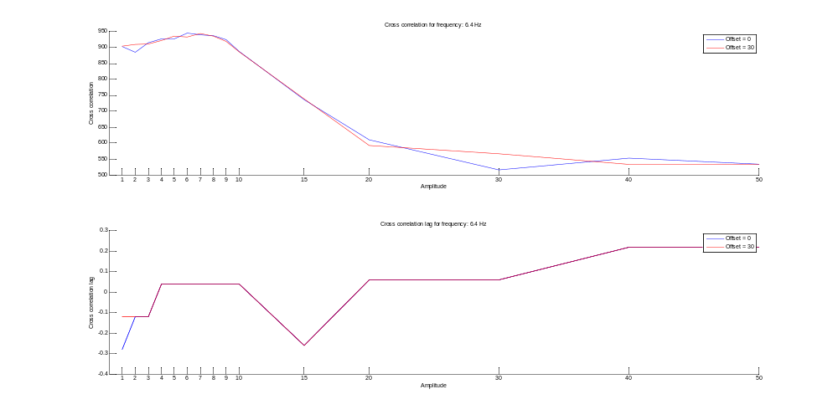

Random problem: f = 6.4Hz, A=9
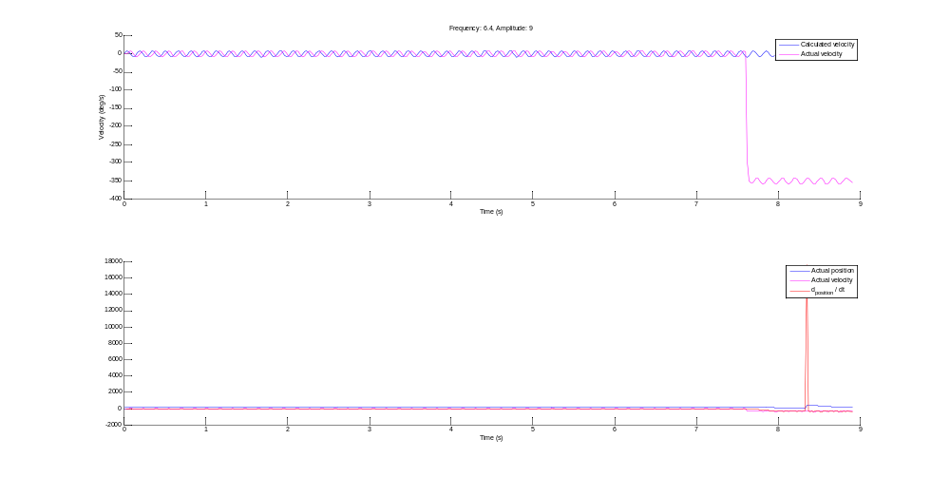
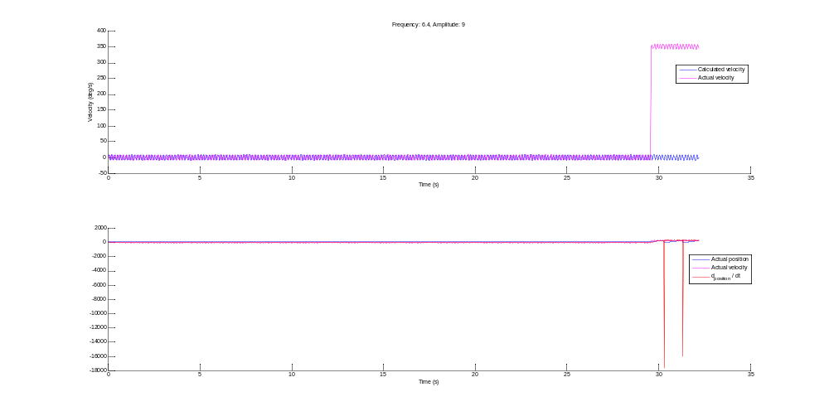

Random problem:
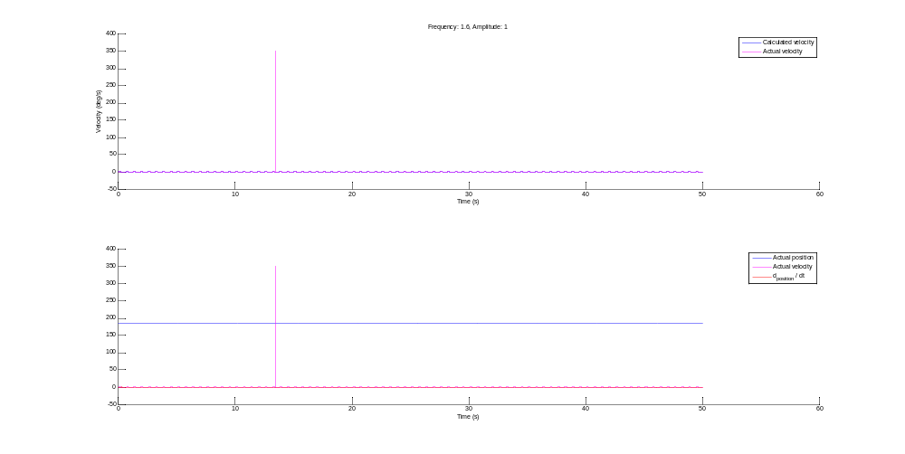
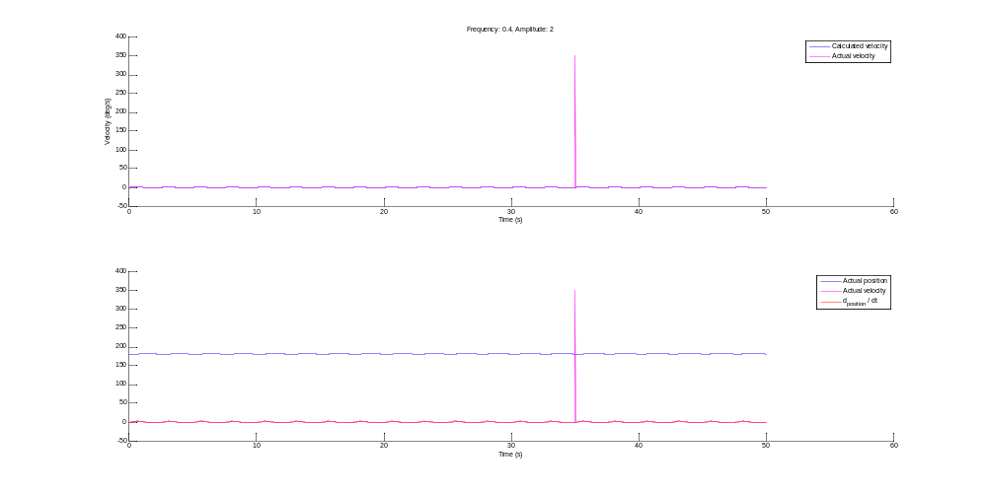

What is the ‘actual velocity’ as reported by the NI board?

NOTE: Currently the Configure Velocity Filter is not used. The Read velocity in RPM function uses axis space

flex_read_rpm_rtn ( Read velocity in RPM)
Reads the filtered velocity of an axis or vector space in RPM.
The Read Velocity in RPM function returns the axis or vector space filtered velocity in RPM.
To minimize the quantization effects of any sampled data system, the instantaneous measured
velocity is averaged by a single-pole low pass filter and converted to RPM before being
returned. The time constant for this filter is programmable with the Configure Velocity Filter
function.
For vector spaces, this function returns vector velocity, the root-mean-square of the filtered
velocities of the individual axes that make up the vector space.
flex_load_vel_tc_rs ( Configure Velocity Filter )
Loads the time constant for the velocity filter and sets the velocity threshold above which an
axis will be considered running.

The Configure Velocity Filter function loads the time constant of the digital single-pole
lowpass filter used to average the instantaneous axis velocity. It also sets the velocity
threshold above which an axis will be considered running. Both parameters have time units
of update sample periods and are affected by the update rate set in the Enable Axes function.
The velocity filter improves the resolution of the velocity reported in the Read Velocity and
Read Velocity in RPM functions by averaging the measured counts or steps per sample over
a programmable number of update sample periods. This filtering minimizes the quantization
noise inherent in any discrete time velocity measurement of low speeds. Due to the aliasing
effects of polling from the host computer, it is often not possible to remove quantization noise
after velocity data has been gathered.
Note Velocity quantization noise is a measurement only phenomenon and does not affect
the FlexMotion ability to accurately control velocity and position at low speeds.
This function also configures the Run/Stop status, which is used for move complete
determination. This Run/Stop status uses the filtered velocity to minimize noise in this status.
The Run/Stop threshold is programmable to account for a wide range of feedback device
resolution and update sample periods and to allow the application to determine when an axis
is going slow enough to be considered stopped. Refer to the Read Trajectory Status and
Configure Move Complete Criteria functions for more information on the Run/Stop status.
The Configure Velocity Filter function is a status configuration function that is typically
called for each axis prior to using the axis for motion control. Once the parameters are set,
they remain in effect until changed. You can call this function at any time to tailor the status
reporting functions as the application requires.

